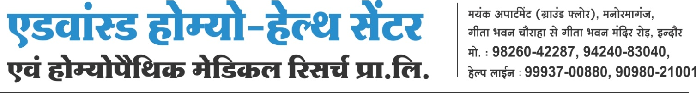

workshop based on Liver and rainy season related diseases oraganised at AD. HO.........Health centre..................

A workshop based on liver and rainy season related diseases was being organised at Advanced ................................. In this workshop Dr A.K. Dwivedi who is a renowned homeopathic doctor and proffesor of homeopathy at homeopathic college said that only increasing of the span of life is not a sign of good health but the quality of healthy living without any critical illness is a sign of good health.. If we talk about global context the schenario of the health and health related issues is very bad in this time.

Keep liver healthy and lead healthy life-----------------

For a good and healthy liver combination of carbohydrate ,fat and protein is utmost necessary ,but unfortunately people are nowadays consuming high fat and low fibre diets ,not only that trend among many people is also increasing who are consuming Alcohol and other harmful breviaries which are directly hampering their livers which is resulting deadly liver diseases.
How to prevent liver diseases .......................

In our diet we must add about 40 % raw fruits and vegetables which increases contain of fiber in our body and cleans our Stomach also . Good quality of Fatty acids are very important for healthy cells and healthy Liver , These Fatty acids are usually found in Fish Oil and some nuts . We should either avoid use of Alcohol or consume in very low or moderate quantity .Research has proved that limited quantity of Red Wine is is good for health but other kinds of Alcohol has no any positive effects on our body and they are harmful for the healthy functioning of liver.

Three Diseases-----------------

3 most dangerous diseases related to Liver are Fatty Liver , Hepatitis and Psyro osis . fatty liver is that condition in in which big drops of fat entered in to the Cells of Liver and interferes in its proper working . There are several reasons of this condition ,mainly malnutrition or wrong habits of eating ,excess use of Alcohol etc.etc.

Disciplined and stress free daily life---------

Healthy liver is only possible when we adopt healthy and stress free lifestyle . we must take good quality of food and include plenty of raw salad ,Vegetables and fruits in it . Apart from that we must took regular exercise habits and lead a stressfree life with the help of Yoga and other methods of meditation instead of medication.In homeopathy we advice to opt balance lifestyle to our patients.

Causes of Liver Disease ---------

* Access use of alcohol
* wrong dietary habits
* Access or incorrect use of Medicines
* Irrregular lifestyle
* Delayed treatment
* Overlooking of the primary symptoms .

* junk food etc.etc.

rainy season is also considered as a season of Diseases,therefore we must take utmost care of our health in this season . Always use clean or boiled drinking water ,use Mosquito nets keep good hygiene to keep bacteria free environment. Homeopathy provides best preventive solutions for all such problems .
In this occasion free booklets were also being distributed . programme was conducted by rakesh Yadav and sahid Shaikh expressed vote of thanks.

